**AI integrated calorie detection and diet recommendation system catering personalized nutrition and assessing risk of mankind health**

**Abstract:** A detailed outline and comprehensive detailing of diet recommendation of individual by taking individual calorie data is portrayed on this study. Existing system mostly deploys common traditional Atwater system or some displays the systems of less efficiency and accuracy. Those systems mostly relies on calorie conversion in numerical and backdated approach relying on mathematical formulations and hypothesis overlooking the patterns of processing as well as variations in ingredients involved as per real world scenarios. Apart from scientific and theoretical measures involved in this matter conventional methods to analyse are diet charts and manual calculators mostly lacks adaptability, personalization along with its ability to assess the risks that are holistic. The developed system thus, leverages highly trained accurate predictive ML models using regression algorithms to predict calorie. Potential risks as in obesity, diabetic along cardiac CRM disorders can be put forward in this Work; Stabilized encapsulation following the workflow in entire GUI demonstrated practically how real time users can see results prone to response, feedback centralized and scalable in methods taken for estimation. Strong potential methods of deployment have been put forward as a next step to carry out the work in development platforms for improvised application ease.

Keywords: ML models, calorie, GUI, diet recommendation, real time, feedback

**Introduction**: Contemporary to the modern age of improvised and advanced era, lifestyle, food habits and other attributes in living has encountered to new varieties of ailments in mankind. Keeping in mind about the health related concerns and diet factors, calorie tracking and recommending proper diet in daily life is always essential to maintain proper health and diet in daily lifestyle. Accurately predicting the diet and calorie is pivotal as it is continuously contributes in reduction of health risks like diabetes, hypertension and many other associated risks. Generalized risks mostly affect the hypothesis instead of working on real time in assuming the diet factor: estimating calories etc. Conventional diet plans involving the tracking and other hypothetical measures mostly fails to affect in recommendation and feedbacks to individuals. Popular theories like Atwater system is very limited to modern day calorie management systems and is only based on foundational models and frameworks to deal in complicated processed foods.

In contrary this method developed in this work mostly learns from real data and also provides real time results and interpretations to drive data in various approaches of integrations. Recommendation engines and other propagandas of classification adopted in this work meaningfully implements health guidance and implications to drive classification and real time prediction. GUI forecasted in this work mostly covers the aspects of adaptations, accuracy and personalization’s for wide possibilities and tracking systems to make healthy tools and platforms.

**Literature Survey**:

In converging with machine learning techniques and food – nutrition science the advancements has led to peak covering all health risk assessment profile and diet recommendation.

Most of the traditional methods mainly Atwater system deals only in calorie specific value and is very narrow. It is limited and has its scope to macronutrients facing challenges in variations of individuals in modern complex diets [1]. Zhang et al, worked on proposal of deep learning method that involves learning estimated calories from various food images that mostly vary in various assessments of diet [2]. Singh et al,worked on various development scales as per individualized recommended diets in analysis of user given datas [3]. Olatunji et al also highlighted the areas of data quality focusing on improvement in developing real time models of ML but accuracy turned up to be low and model didn’t worked to that extent but it was reliable to limited scope [4].Li et al worked on implementation of nutritional supplements that mostly caters to ratify the need of individual diets [5]. Chen et al, worked on comprehensive survey that contributes to ML / Dl classification in foods characterizing the challenged encountered and faced in accomplishment to visual heterogeneity [6].

Cardiovascular health is broadly classified and taken in context for this work where Patel et al., emphasized the use of SVM in addition to linear regression models to tailor dietary supplements as a complementary requirement. Review in subsequence has been done to predict the risk of coronary blocks and interpretable models for better alignment with biological models [7]. Wang et al., similary worked on proposal based mechanisms that mostly find out the integrations of data based on sequence for improvised accuracy [8].

Development of various nutritional databases has been taken into deep considerations by Liu et al. Who always worked on YOLO detection of objects making accuracy to much higher and stable rates of food detection mainly fast food rates [9]. Ramos et al., specifically addressed the challenges developed and proposed proper evaluation in approaching ML models that are built with trust and proper performance [10].

Ahmed et al. worked on a survey and provided an in depth insight on detailed survey about approaches in machine learning and deep learning techniques mostly working on patient relevance and outcomes [11]. Panaretos et al. worked on proper demonstration of predictive models and mostly shown the outcomes for diabetic patients [12].

Studies taken into consideration mostly take up the transformation that helps in demonstrations of ML in food calorie as well as nutrition and mostly on traditional theoretical approaches paving path to create something more comprehensive accurate and compact in single step.

**Methodology :**

Figure 1 illustrates the methodology used in the entire project work it mainly comprises of taking data input till visualizing in GUI.

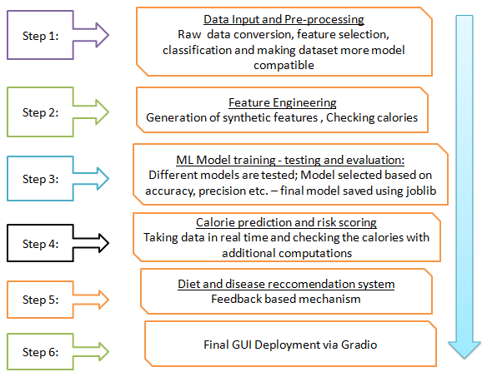

Figure 1: Methodology

Initially dataset is taken and uploaded. Dataset is not totally open source as few features are also implemented by end user. Data cleaning takes place at very outset followed by selecting proper features and generating the absolute synthetic features followed by calculating the Atwater reference. The model is trained further based on several algorithms and the best performing algorithm is finally selected. The model training and selection preceded by selection of best model saved by joblib and moreover the predictive logic is placed forward. The risk assessment logic is mapped to various conditions in classifications. Diet recommendation modules mostly mimic the use of nutritionists with GUI development and deployment for real time use and post applications.

**Results :**

Results mainly depicted the following –

* MAE, MSE along with R2 score.
* Key aspects in functional terms mostly vary the prediction output and probable estimation of diseases that is estimated.
* Personalized diet tips in GUI integrated with ML output creating a difference between ML and traditional values.

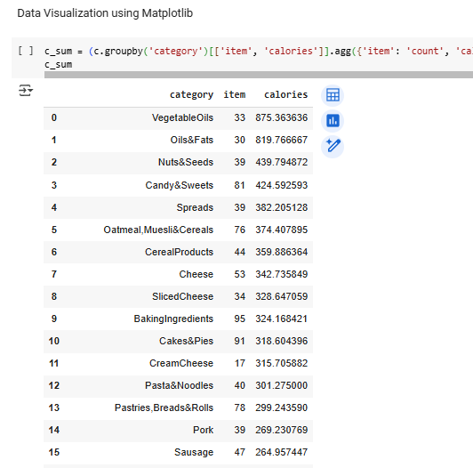

Figure 2: Data Visualization

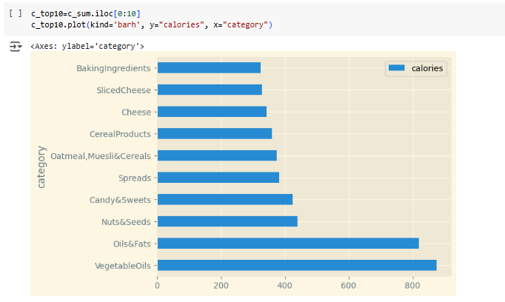

Figure 3: Segregation by category

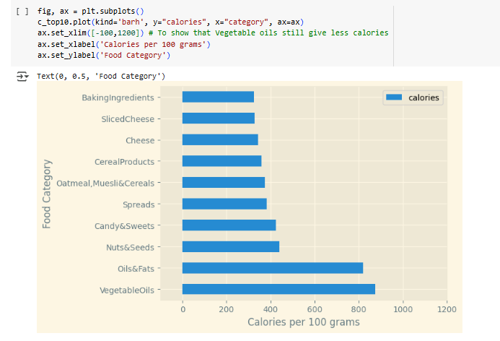

Figure 4: Categorizing food in 100 gm calorie

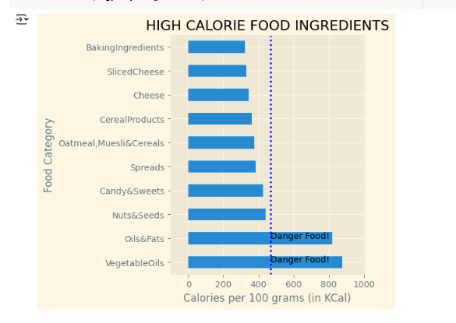

Figure 5: Identifying high calorie food items

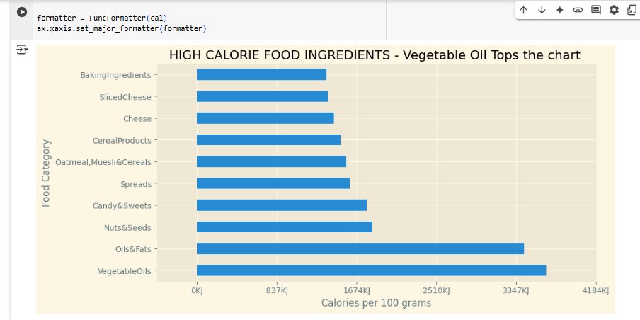

Figure 6: Separating the ingredients

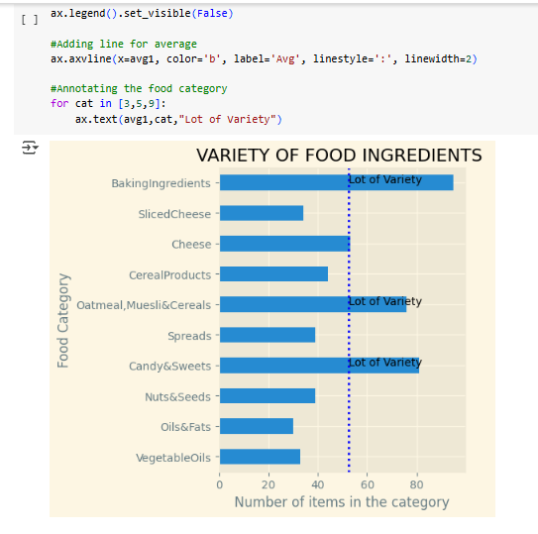

Figure 7: Checking the variety

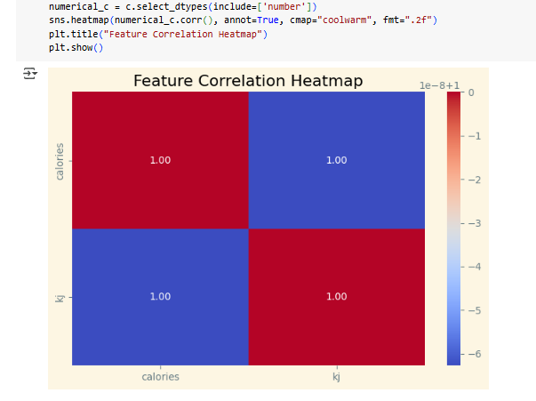

Figure 8: Calories and kJ correlation heatmap

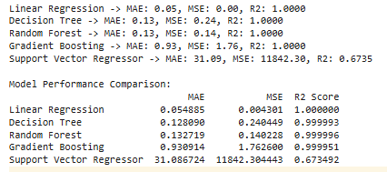

Figure 9: Comparison of various models based on various parameters

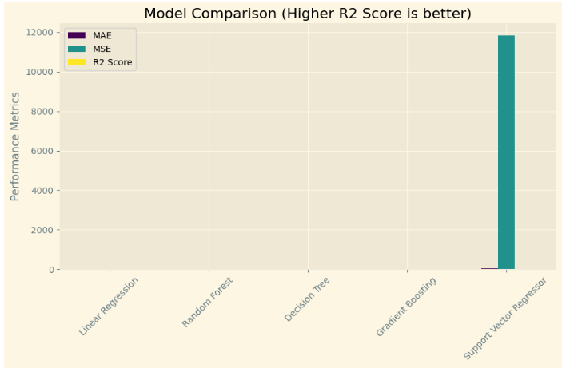

Figure 10 – Model comparison

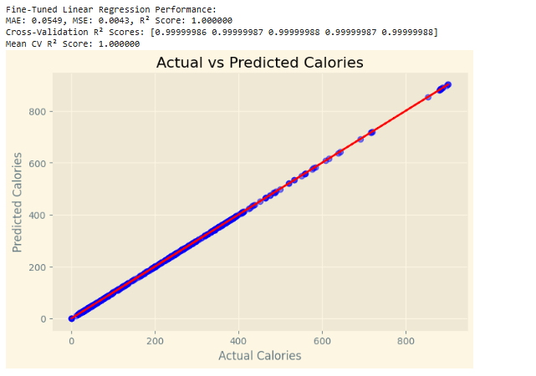

Figure 11: Checking the performance of linear regression

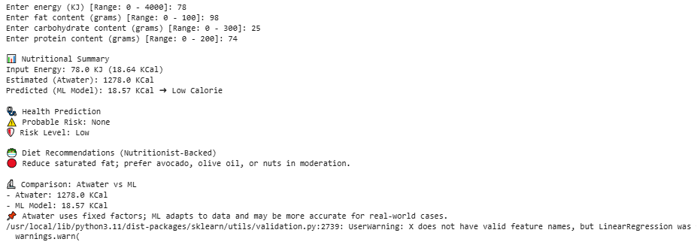

Figure 12: Prediction

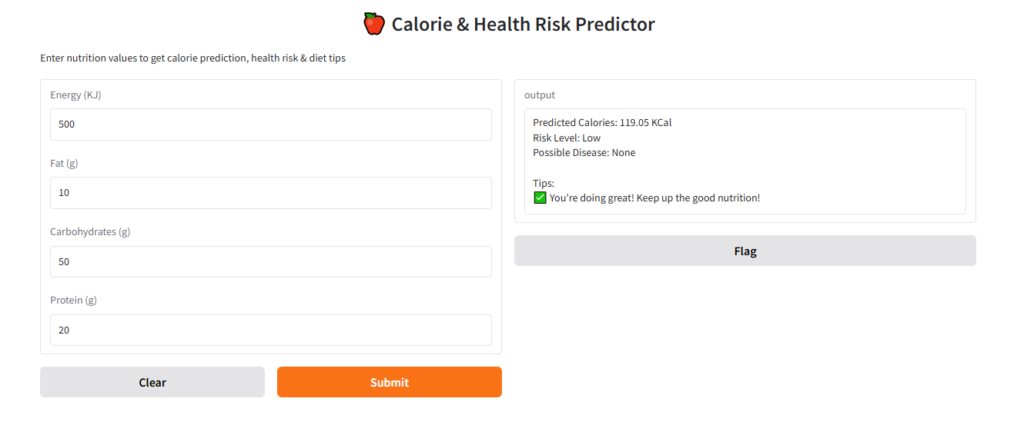

Figure 13: Live interactive GUI

**Discussion**

Proposed system leverages ML algorithms and significant implementations in outperforming traditional methods to detect and predict calorie in food along with diet recommendation. It significantly highlights the differences and its key unique areas to be more flexible and variations in composition, variation along with checking the complexity of foods, Dynamically interpolations makes the system more complex aware and offering large scale predictions to models. It alo lays out large score mechanism of risks and also includes concerns that involves major and minor health ailments making it more advisory and awareness tool.

The system developed more is focused into macro nutrient analysis and continuous to adhere to guidance followed by actionable access parameters for deploying gradio in live GUI in ML backend algorithm.

**SWOT Analysis**

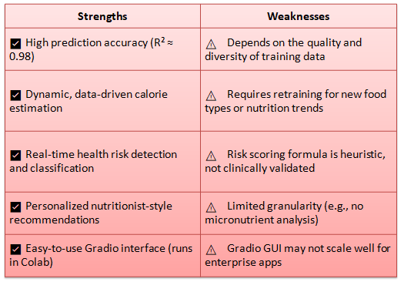

Figure 14: Strength vs. Weakness

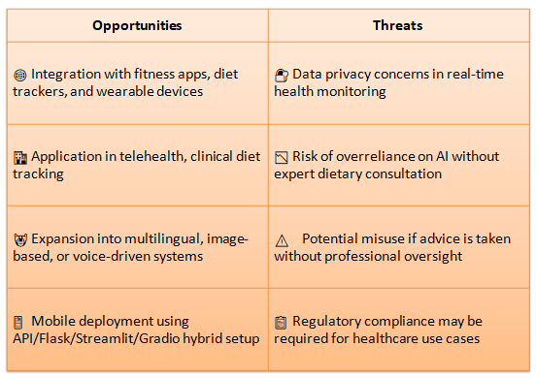

Figure 15: Opportunities vs. Threats

**Conclusion**

Project successfully demonstrated the ML framework to predict calorie and assess the health risks in significant measures of progressive improvement. Leveraging multiple data, multiple ingredients and data gathered at once make up the risk classification setup of diet recommendation. Predictive accuracy of 98% makes the most of the setup in the backend in confident way. Gradio based live GUI system ensures the interactive access to fitness professionals, nutritionist and other personnel to promote data driven delivery of results, in preventive and protective healthcare eradicating all sorts of possible measures of disease. Thus, making the system more impactful and making a new channel to implement the application into supportive systems, edible predictions, EHRs and other health technologies.

**Acknowledgement**

We acknowledge Department of IT and CA JISCE for their support and there are no applicable funding in this work.

**References**

* 1. Kaur, H. & Kumari, V., 2022. Predicting risk of obesity and meal planning to reduce the obese in India using machine learning. Endocrine, 76(3), pp. 512–522. ​
  2. Zhang, Y. et al., 2022. Dietary assessment by food image logging based on food calorie estimation. In: Proceedings of the International Conference on Artificial Intelligence and Big Data. Springer, pp. 107–115. ​
  3. Singh, A. et al., 2023. Personal nutritionist GUI for diet recommendation system using machine learning. In: Proceedings of the International Conference on Smart Computing and Communication. Springer, pp. 28–36. ​
  4. Olatunji, O. & Adebayo, S., 2021. Artificial intelligence and machine learning for health risks prediction. In: Proceedings of the International Conference on Artificial Intelligence and Applications. Springer, pp. 12–20. ​
  5. Li, X. et al., 2023. Design personalized nutrition supplement recommendation system based on machine learning. In: Proceedings of the International Conference on Intelligent Computing and Applications. Springer, pp. 17–25. ​
  6. Chen, L. et al., 2022. Evaluating machine learning technologies for food computing from a data perspective. Multimedia Tools and Applications, 81(3), pp. 16513–16530. ​
  7. Patel, M. et al., 2023. Artificial intelligence for risk assessment on primary prevention of coronary artery disease. Current Cardiovascular Risk Reports, 17(1), pp. 7–15. ​
  8. Wang, J. et al., 2023. A unified approach to designing sequence-based personalized food recommendation systems. Neural Computing and Applications, 35(1), pp. 1808–1820. ​
  9. Liu, Y. et al., 2024. Deep learning-based automatic food identification with numeric label. Multimedia Tools and Applications, 83(2), pp. 20648–20660. ​
  10. Ramos, R. et al., 2023. Machine learning models' assessment: trust and performance. Medical & Biological Engineering & Computing, 61(1), pp. 3145–3160. ​
  11. Ahmed, S. et al., 2023. Healthcare predictive analytics using machine learning and deep learning techniques. Egyptian Informatics Journal, 24(1), pp. 108–120. ​
  12. Panaretos, D. et al., 2022. Effects of personalized diets by prediction of glycemic responses on glycemic control and metabolic health in type 2 diabetes: a randomized crossover trial. BMC Medicine, 20(1), pp. 254–266